Velocity relationship in leveled instrument coordinate and earth coordinate

Denote 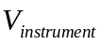 the leveled instrument velocity, 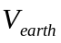 the velocity in earth coordinate.

The relationship between and is:
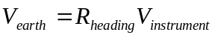

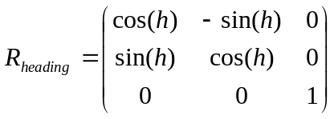
Here is the corresponding heading.

